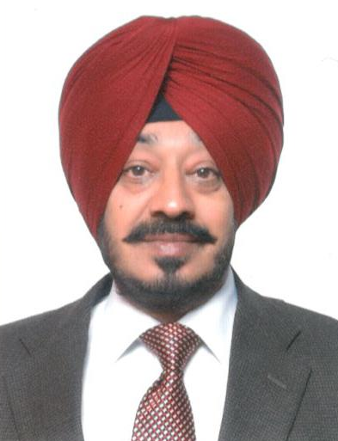

AMARPAL SINGH
Sr. General Manager

Mr. Amarpal Singh is working with NITCON since the year 1991, prior to which he served with Punjab Tractors Ltd. (Swaraj Group) for 3 years where he worked on Project Expansion / Modernisation of the Foundry Division. On joining NITCON, he has provided yeoman service to the organisation, has handled almost the entire range of NITCON advisory services on offer viz. Techno Economic Feasibility Studies, Techno Economic Viability Studies, Project Appraisals, Market Research Studies (Secondary), Diagnostic Studies, Impact Assessment Studies, Asset Valuation Studies, Business Valuation, Stock Audits, Financial Restructuring (CDR, BIFR cases etc.), Technical Due Diligence, Skill Trainings etc.
He had joined NITCON as Project Officer and is presently serving as Senior General Manager. During his over 3 decades career he has dealt with Techno Economic Appraisals, Market/ Technical /Financial assessments for diverse SME sectors as well as for Mega / Super Mega Projects pertaining to Steel Rerolling Mills, Mini Steel Plants, Forgings, GI / SAW Pipes, Sugar Mills, Wire Drawing, Agro Products, Distilleries, Ethanol, Beer Plant, Soft Drinks, Fertilizer, Bathroom Fittings, Mini Hydro, Printing & Packaging Paper Industry, Modern Abattoir, Pharma, Hospitals, Education Institutions like Engineering / MBA / Nursing Colleges, Residential / Industrial / Golf Mega / Super Mega Projects, Cricket Stadium-cum-Sports Complex, Shopping Mall-cum-Hotel, Roads, Hotel etc. to mention a few. He has also been instrumental in securing funds for Government of Punjab/ Industry Clusters under various Central Government schemes like MSE-CDP, MIIUS.
Off late, he has also been closely involved with Skill Trainings where-after curriculum alignment with NOS norms has been taken up in right earnest by NITCON to meet the requirements of the sponsoring institutions.
He is a Bachelor of Engineering in Metallurgy from Punjab Engineering College (PEC), Chandigarh with Masters of Business Administration (MBA) from IGNOU, New Delhi.

