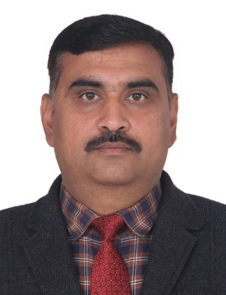

Parveen Bhargava
Senior Manager

Mr. Parveen Bhargava, has 25+ years of professional experience with distinction of executing consultancy projects for various Entrepreneurship Development Programmes (EDPs), Faculty Development Programmes (FDPs), Skill Development Trainings, Rural Entrepreneurship Development Training Programme etc. He delivers lectures in EDP training programmes on various topics including guidance w.r.t. setting up of new industries and has achieved a high success rate of Entrepreneurship Development in his area with many trainees having set-up their own ventures/ units. He has developed a good liaison with District Administrations as well as local MSME Clusters of Ludhiana, Jalandhar and nearby Districts.
He has successfully executed various projects in skill development space for reputed organisations like Deptt. of Science & Technology (DST), Ministry of Food Processing, NHFDC, NSKFDC, Power Grid, SUDA, Welfare Department Punjab, RECL, to name a few.
He has also been associated with technical consultancy assignments like Assets Valuation Studies, Market Research, Impact Assessment Studies, Energy Audits, etc.
He joined NITCON as Trainee in 1995 and is presently serving as Senior Manager, prior to which he served with Crystal Switchgears, Ludhiana as a Lab Incharge-cum-Electrical Engineer for about 1½ year.
He is Bachelor of Engineering (Electrical) from Guru Nanak Dev Engineering College, Ludhiana. He is a Fellow Member of Institution of Engineers (India) and Institution of Valuers.

